# ‘ RELIGIOUS AFFILIATION: HOW IT AFFECTS THE POLITICAL PARTICIPATION OF UNIVERSITY OF IBADAN STUDENTS DURING THE 2023 ELECTIONS ’

## DATA PRESENTATION

The details of the survey are analyzed below using charts, graphs and tables for presentation of data.

### CHART 1: TOTAL NUMBER OF RESPONDENTS AND THEIR RELIGIOUS AFFILIATIONS.

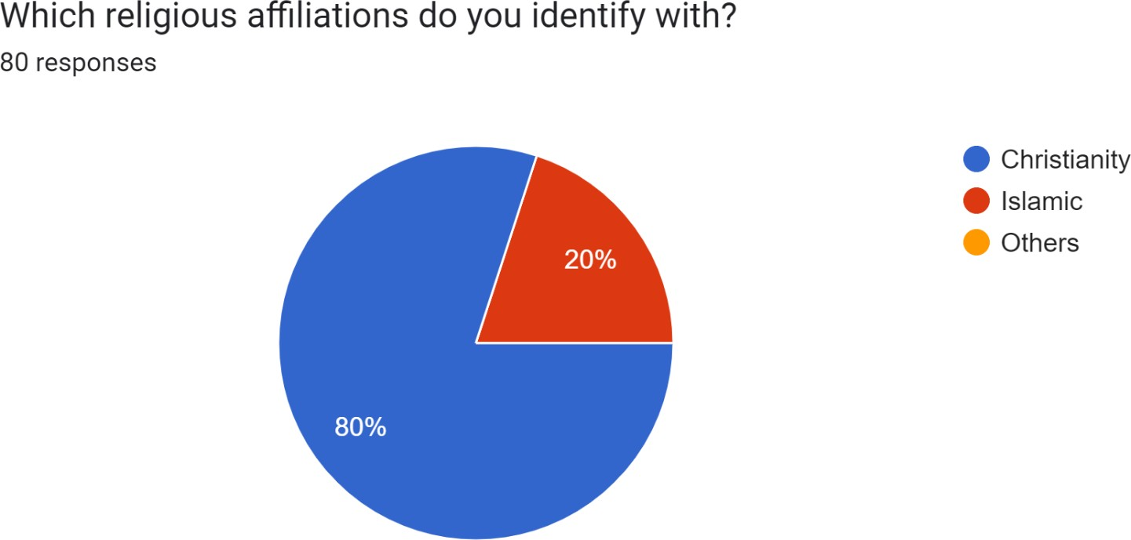

The study is composed of both christian and islam students: 80% are christian respondents and 20% are islam respondents making a total of 80 respondents.

### CHART 2: HOW STUDENTS VOTED DURING THE 2023 ELECTIONS

The bar chart below displays the ratio of students that voted to those that did not. A greater proportion of respondents that were not accredited, registered or able to vote 41 ( 51.25%) and only a fair portion 39 (48.75%) were able to vote.

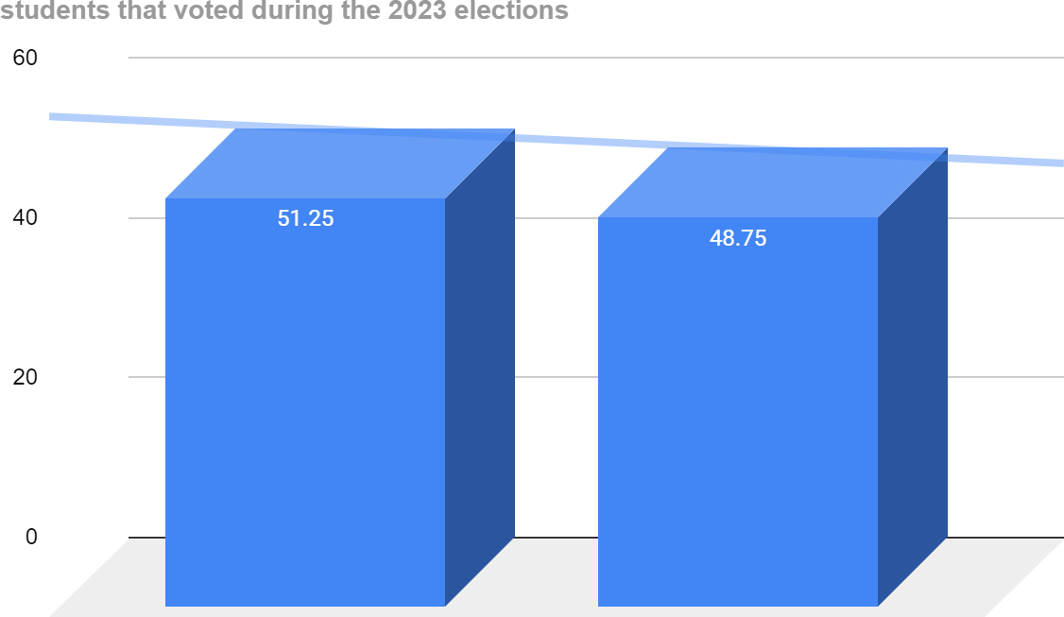

### CHART 3 - 7: HOW RELIGION INFLUENCED VOTING DECISION AND PARTICIPATION

**T**he following chart displays how out of 39 respondents that voted ( 51. 25%), only 28 were Christians. In the 28 Christian Voters, the following data was extracted:

**CHART 3:** In 39 voting respondents, just 28 are christians. In the 28 christians (71.79%) only 7 (25.0%) were influenced by their religion to vote in the 2023 elections.

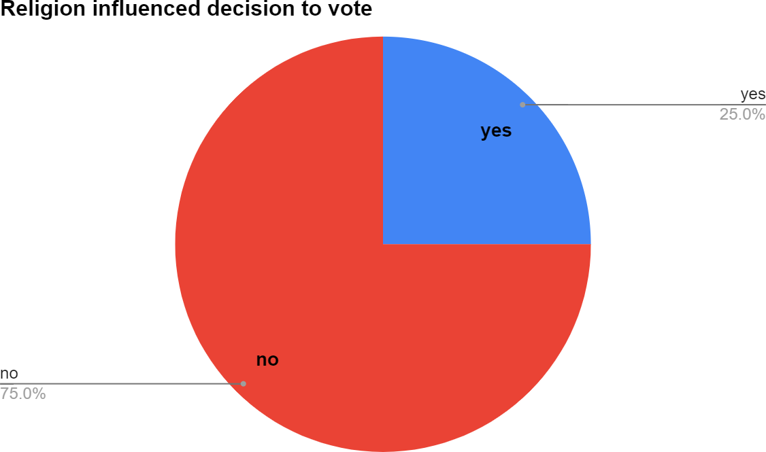

### CHART 4

**O**f 28 christians, only 5 were influenced by religion in knowing about a candidate.

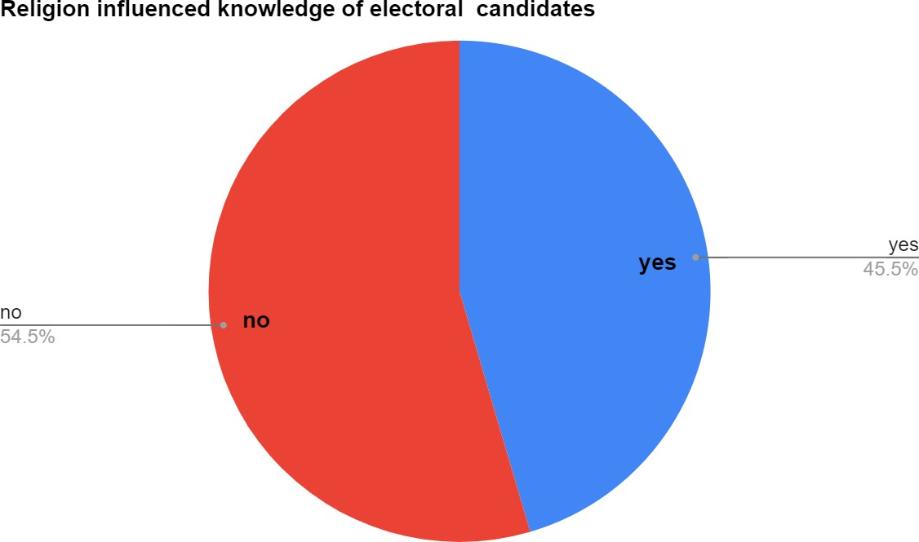

### CHART 5

**O**f 28 christians, only 9 were influenced by religion in knowing to participate in electoral process

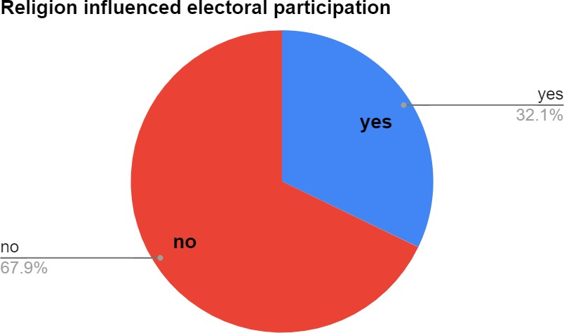

### CHART 6 AND 7

**This displays how Islam voters voted. Out of 39 respondents, 11 were Islam voters and the following charts shows how religion influenced their decisions:**

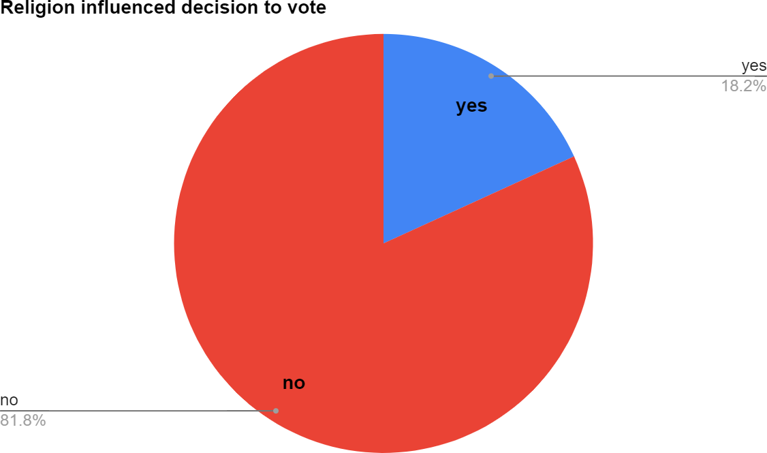

### CHART 7:



Chart 7

### VOTERS’ PARTICIPATION IN THE PRESIDENTIAL AND GUBERNATORIAL ELECTIONS CHART 8:

Of 11 muslim respondents that voted, 5 responded that religion influenced who they voted at the presidential level and 2 believed religion influenced their voting behavior at the gubernatorial level. The remaining 4 voted at other elections like senatorial, house of representatives, etc.

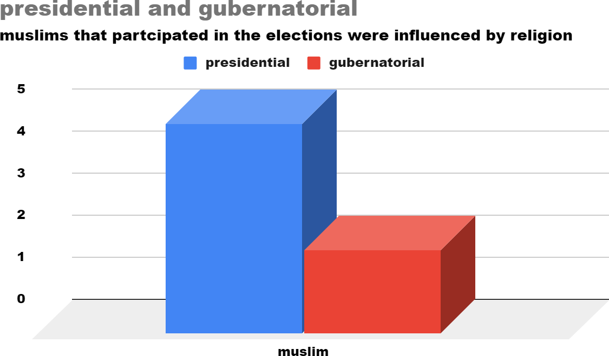

### CHART 9:

Of 28 CHRISTIAN respondents that voted, 19 believed religion influenced who they voted at the presidential level and 9 believed religion influenced their voting behavior at the gubernatorial level.

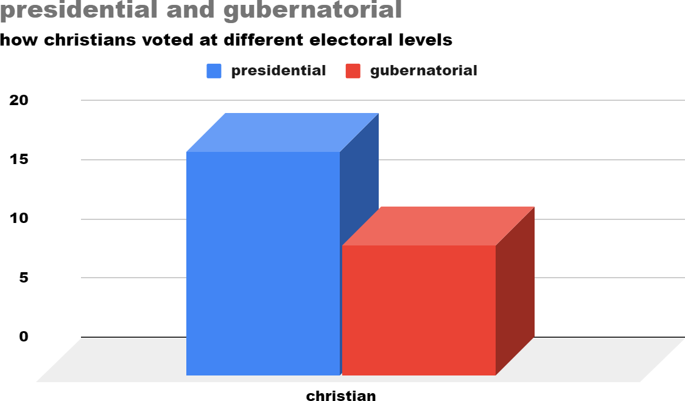

## DATA ANALYSIS

### Determine how religion affected the level of awareness of UI students concerning the election and how religious affiliation influenced who UI students voted for

In answering these research questions, data presented on charts 3 - 9 will be used. To determine how much students are influenced by their religious affiliation, questions such as ‘rate your level of commitment to religious activities’ and ‘how did it affect you' were asked. Chart 1 to 6 depicts how little religion affects the voters' choice of UI Students. 39 respondents out of 80 that are accredited, registered and able to vote,only 9 (23%) are influenced by religious affiliation and the higher portion 76.92% reveal that religious affiliation does not affect their decision making. This data also shows that only 45.5% christians were impacted by the religion in gaining knowledge on electoral candidates and a similar percentage for muslims also.

This data begs the question on how and why scholars believe religion affects political participation. Religion itself interacts with secular structures and pressures to encourage or deter individuals from engaging in the political world. The average response on why people participated was; ‘voting is their civil responsibility’ and ‘they want to participate in building their nation’. Our findings point us to how the social environment largely plays a part in people's

actions. The University ecosystem encourages critical and independent thinking including the respect for diverse perspectives and differences. These are factors that make religious affiliation a possible non-important determinant of how students participate in politics in the grand scheme of things thus, educational experiences may play a more significant role in shaping the political behaviors of university students, outweighing the direct influence of religious backgrounds

### Determine if religious affiliation influenced UI students to participate or not participate in the 2023 elections. :

In carrying out this survey, a heavy reliance on the truthfulness of respondents was required and depended on. However, human unpredictability and indeterminacy remains a problem in political science because of some issues contained in this data.

In gauging how religion influenced political participation, open-ended optional questions were asked and reviewing it showed the respondents were mainly not influenced by their religion. However, upon subsequent review, the data shows that a higher percentage of those that voted during the presidential election - Christian or Muslim - were heavily influenced by their religious affiliation. The same applies for the gubernatorial elections. This is shown in the last two bar charts (Chart 8 and Chart 9)

**Chart 3 to Chart 5** displays how only 32.1% of christians were influenced to participate, only

45.5% were influenced by religion to know about electoral candidates and only 18.2% were influenced by religion to vote. From this, we observe that a good majority of christians were not influenced by their religion. Same applies for the muslims ( Chart 6 and 7).

**Chart 8 and 9 displays** how the voters, although they perceive themselves to have been neutral, were still heavily influenced by religion. 19 ( 67.85%) of christians that voted at the Presidential level were influenced by religion and 5 (45%) of muslims that participated at the presidential election were influenced by religion also. Religion is a credible influence on political participation albeit, other social and secular structures especially in the environment of the voter determine the extent of its influence as shown in the responses of the University of Ibadan students.

## REFERENCES

Fastnow, Chris, J. Tobin Grant, and Thomas J. Rudolph. (1999, December). Holy roll calls: Religious tradition and voting behavior in the U.S. House. *Social Science Quarterly*. 80(4), 687- 701.

Layman, Geoffrey C. "Religion and Political Behavior in the United States: The Impact of Beliefs, Affiliations, and Commitment From 1980 to 1994." Association for Public Opinion Research 61.2 (1997).

Merriam, W. (Ed.) (1980). Encyclopaedia of religion. New York: Prentice Hall.

Obiefuna, B.A.C. (2018). Religion and human relations in contemporary Nigeria: The wounds and the healing. An inaugural lecture of Nnamdi Azikiwe University, Awka. Onitsha: Noben.

Onapajo, H. (2012). Politics for God: Religion, politics and conflict in democratic Nigeria. The Journal of Pan African Studies. 4. 9. 42-66

Rodney, W. (1981). How Europe underdeveloped Africa. London: Bogle-L’ouverture.

Sodiq, Y. (2009). Can Muslims and Christians live together peacefully in Nigeria? The Muslim World, 99, 646-688.

Ugwu, C. O. T. (2002). Man and his religion in a contemporary society. Nsukka: Chuka Educational Publishers.

Verba, Sidney, Kay Lehman Schlozman & Henry E. Brady. 1995. Voice and Equality: Civic Voluntarism in American Politics. Cambridge, Mass.: Harvard University Press